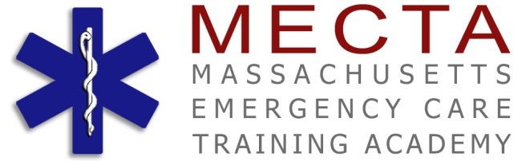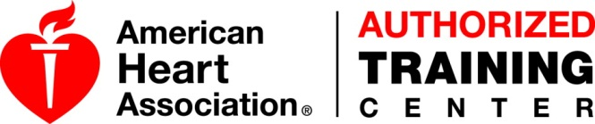
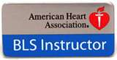
Are you interested in becoming an
American Heart Association Instructor?
Put your heart into training, teach to save lives!

Doing so is "as easy as 1-2-3" after consulting with MECTA Academy, an American Heart Association Training Center.
Requirements include:
1. Become certified in AHA CPR at the Healthcare provider level (prerequisite)
2. Complete the Core Instructor Course
3. Complete a discipline-specific instructor course in Basic Life Support (BLS) or Heartsaver CPR – AED, First Aid, and
4. Get monitored by an AHA Training Center Faculty
Logistics:
Basic Life Support (BLS) Cardiopulmonary Resuscitation (CPR) Automated External Defibrillator (AED) Instructor Course $350.00
(Pre-paid)
American Heart Association Heartsaver First Aid & CPR Instructor Course: Enables the instructor to teach CPR & first aid to the community and workplace that are not healthcare providers. Student must have a current AHA Heartsaver CPR Card covering adult, child and infant CPR.

Email Instructor Candidate Application along with copies of:
>An active/ unexpired AHA Basic Life Support for Healthcare Provider CPR/AED course completion card.
> Your AHA Core Instructor Course, course completion certificate
(Bring the original documents to class)

AHA CPR Instructor Course Application PayPal

