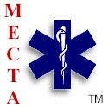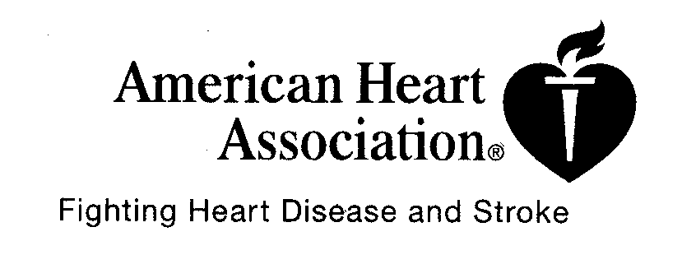
2010
MECTA, Inc. • American Heart Association Emergency Cardiovascular Care Program Course Roster

HCP- BLS Initial Renewal Training Center: MA. Emergency Care Trng Ag/Academy –MECTA
Heartsaver CPR Adult Child Infant
Heartsaver AED Adult Child Infant Training Site Name
Heartsaver First Aid -PEDI Initial Renewal (W/Training Center Agreement):
Heartsaver First Aid/CPR/AED Initial Renewal Course Location:
CPR for Family & Friends
CPR in Schools Course Director:
ECSI First Aid / CPR Initial Renewal

BLS Instructor Initial Renewal Mail Cards To:
BLS Training Center Faculty Initial Renewal
First Responder Initial Renewal

Course Start Date/Time: Course End Date/Time: Total Hours of Instruction:

Student-to-Manikin Ratio: Number of Cards Issued:
Assisting MECTA Instructors
Name Inst. Card Exp. Date Module/Station | Name Inst. Card Exp. Date Module/Station
1. | 5.
2. | 6.
3. | 7.
4. | 8.

I verify that this information is accurate and truthful and that it may be confirmed. This course was taught in accordance with the AHA 2005 guidelines.

Signature of Course Director/Lead Instructor Date
PLEASE PRINT
NAME: PRINT your name as you wish it to appear on your card. | Address | Phone | Email | Exam Score | Date Card Issued
1.

2.

3.

4.

5.

6.

7.

8.

9.

10.

11.

12.

13.

14.

15.

16.

